

G-30, Inavolu, Beside AP Secretariat Amaravati, Andhra Pradesh-522237

**STUDY ASSISTANT**

# Under The Guidance of -

Dr. Nihar Ranjan Pradhan

TEAMATES:

|  |  |
| --- | --- |
| **NAME** | **REGISTRATION NO** |
| Rakshita Dahiya | 22BCE8197 |
| Chandsi Solanki | 22BCE8571 |
| Puneet Ameta | 22BCE9274 |
| Abhishek Singh | 22BCE7566 |
| Srinjoy Das | 22BCE8583 |
| Ayush Bhagasra | 22BCE8132 |

## ABSTRACT

Students tend to get carried away and distracted easily while studying. This problem is common with all children and especially children with ADHD (Attention-Deficit/Hyperactivity Disorder). When they go unmonitored, children are prone to pretend to be studying or doing other activities. Many sleeps during their study session. To overcome the problem of children going unsupervised we have come up with the idea of "Study Assistant". The concept is to monitor the child during the study session and nurture them with the care that they require to be motivated and noticed. Our project would detect the face of the person and their eyes to alert them if it's closed for a long time which will also ensure that the person is present there physically, it would alert them if their body posture seems to be bad or in an unhealthy manner, it will remind them to take sedentary breaks and water breaks, and it will record the session timing from start to end to keep track of their goals. The functionality of the project as a whole prototype was built and successfully executed to give the desired outcome. Each function module was integrated into Raspberry Pi and the hardware components such as the camera, LCD screen, buttons, and speakers to make the product work as expected.

# INDEX

|  |  |
| --- | --- |
| **1** | **Introduction** |
| **2** | **PROBLEM STATEMENT** |
| **3** | **Objectives** |
| **4** | **Methodology** |
| **5** | **Results** |
| **6** | **Conclusion and Future Scope** |
| **7** | **References** |
| **8** | **Codes** |

## INTRODUCTION

If you’re okay with killing time, it’s not scarce enough.

Time is scarce, life is short, and as the grains of sand slip through the hourglass, so does the precious gift of time. Once gone, it disappears forever. We all know these things. And yet, at work and home, we’re so lost in a trance of distraction that killing time has become a chronic disease.

Much of modern leisure is slothful. It’s spent in a state of passive, shoulders-slumped consumption where we inhale processed foods that make us fat, TV shows that numb instead of inspiring, and advertisements that create anxieties that only shopping can relieve. The lethargy of modern leisure says that movement is tyranny as if humans are batteries to be recharged by the electricity of mindless entertainment.

How many times have we sat down to study, only to scroll Instagram the next minute? Living in a generation where we get endless entertainment in a couple of clicks, it's an arduous task to focus on one thing for a long period of time.

How many days breeze past only for us to realize, we haven’t done what we set out to do? Even if we make up our mind and sit down to focus, we often overlook our bad posture, which may be detrimental to our health. Keeping ourselves adequately hydrated is also imperative. In short, we need study etiquette, a collection of good study habits, like planning ahead and keeping track of our progress, etc. This is exactly what we aim to solve with Study Assistant.

Study Assistant is your personalized study buddy with an inbuilt Pomodoro timer, which helps you to schedule your work and keep track of your progress; posture corrector, which gives a prompt if your posture is not ideal; and also reminds you to take frequent water breaks to keep you hydrated. Whether you are a parent worried about your child’s study habits or a person who needs a nudge to get the ball rolling, Study Assistant is the right fit for you.

**PROBLEM STATEMENT:**

Students experiencing notifications or phones near them distracting and making them waste time instead of concentrating on studying.

They are not able to avoid the phone completely due to basic functions it provides during studying like alarms ,reminders , music , time.

Students facing the problem of neck pain and back pain due to the wrong posture while studying which limits their ability to study for a long time duration

Students facing the problem of dozing off during studying which goes out of their  
control and thus missing important deadlines.  
  
Parents are not able to monitor their kids or know about their study activity due to  
their busy schedule in life which makes the parents worried about their kids.  
  
Students missing the parents presence near them and thus missing the motivation  
and appreciation factor by their parents and the care they show in asking the  
students to take water breaks , sedentary reminders

## OBJECTIVES

The main objective of the project is to help the students stay awake and be centralized while studying when no one is present to monitor them

To build and device that will detect their face and alert them to correct their posture if seems bad and unhealthy

To record the progress and the duration of their study time and collect a log of the data when they are unsupervised

To ensure that they are nurtured with the care that they might have when being monitored and remind them to take necessary sedentary breaks to keep them stress-free

To notify them about their progress to keep them positive and motivated

## METHODOLOGY

1) The project provides the students/well-wishers with the following information:

* Duration of work time

* Information regarding posture

* Sedentary breaks

* Water break reminder

2) Two Buttons have been used for user inputs in the proposed project.

3) A camera is used to observe the user for the collection of essential data such as posture and presence of the person.

4) The output is displayed using a 20x4 LCD screen.

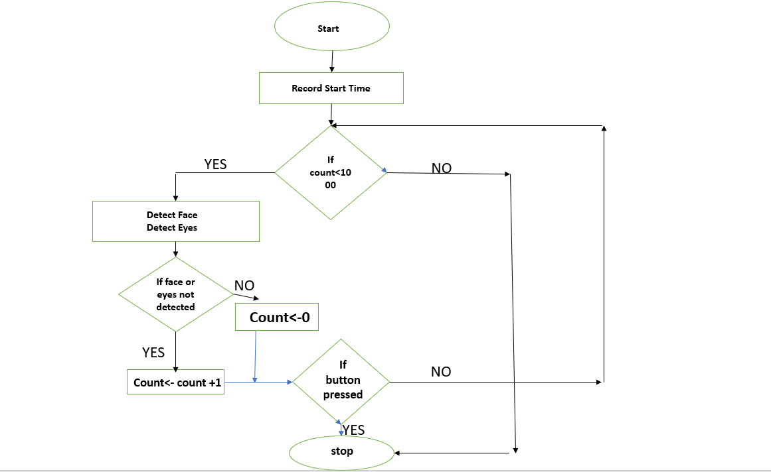

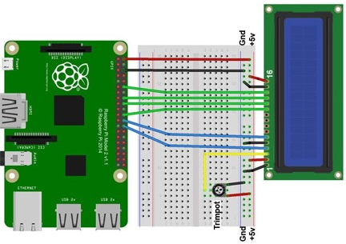

**RESULTS**

As a result of this project we were able to do live eye tracking of the user and store the data (total time of study) in excel. This keeps track on the user and does not allow him/her to fall asleep while studying and gives proper interval of breaks to refresh. This helps the user to concentrate with full interest on studies without any disturbances or distraction.

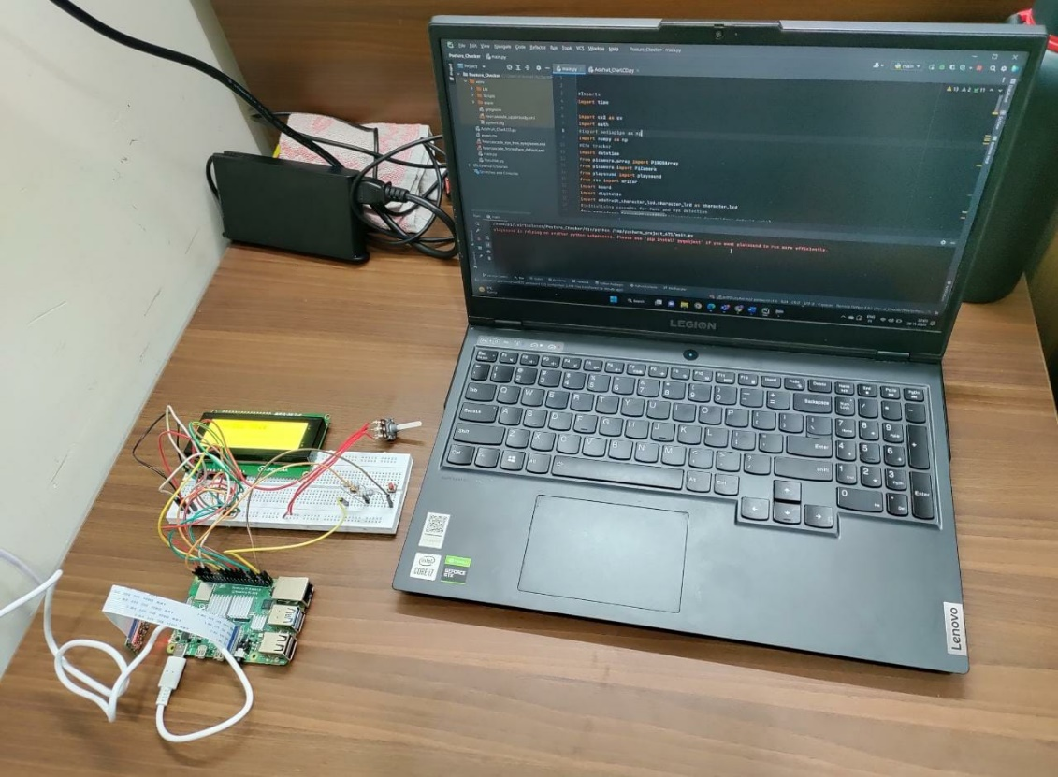

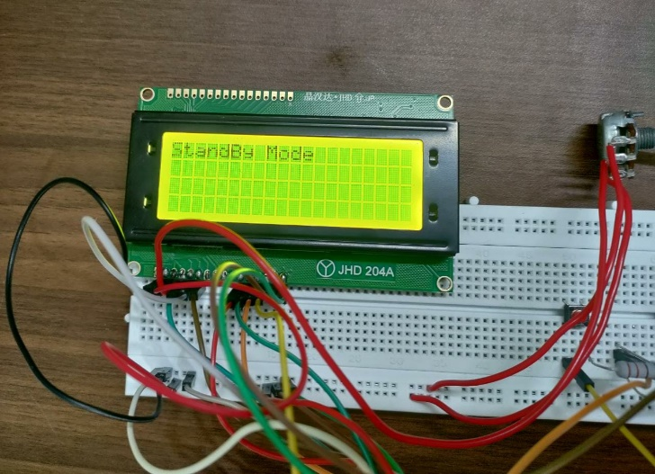 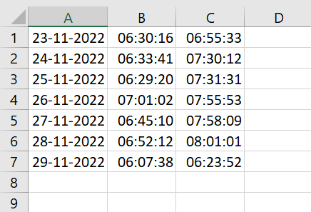

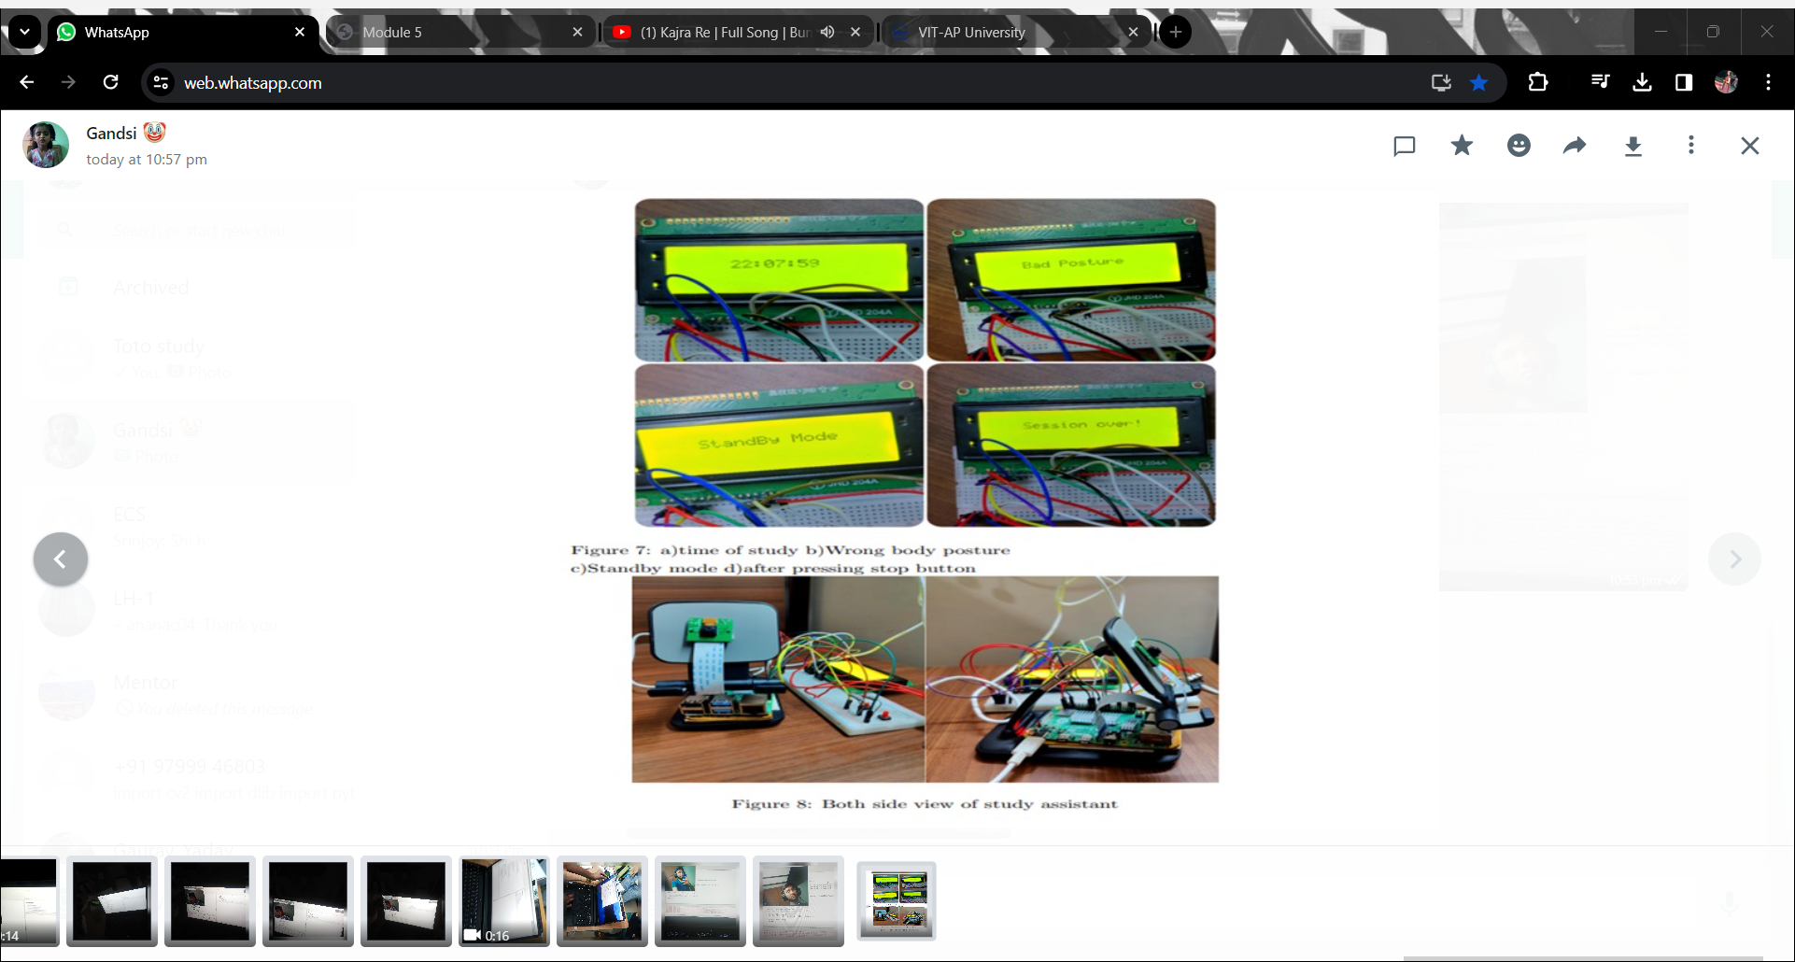

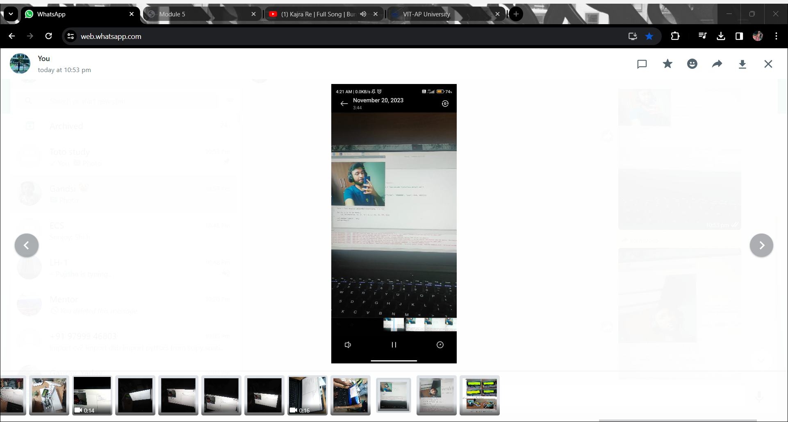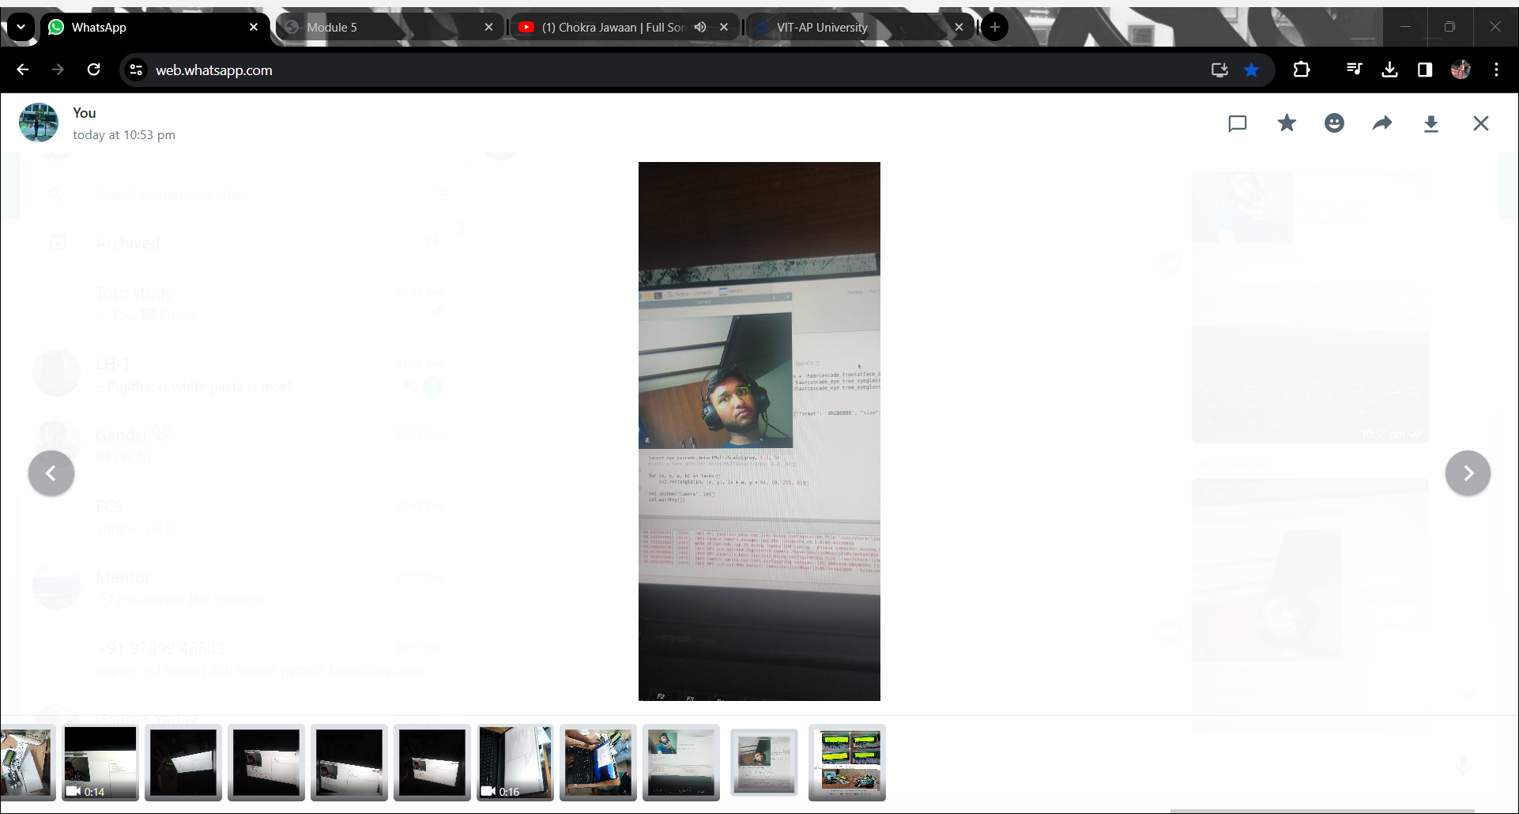

## CONCLUSION AND FUTURE SCOPE

The project helps the users avoid distractions by replacing the basic functionalities of the phone helping them fully focus on their studies. It helps in correcting the posture of the user and helping them sit for long hours with a lesser physical strain. Parents and students have the ability to track the data of the studying session helping them to improve the studying experience. Thus the users can improve the productivity and quality of their studying experience with the help of this project.

FUTURE SCOPE:

Further this project can be improved with the help of an app that can display data of the users with the help of infographics. The project can be integrated with a more interactive and bigger display with visual graphics enhancing the studying experience. A speaker can be integrated to play the warnings and other sound outputs. An AI voice assistant can be added to provide commands and interact with the device.

## REFERENCES

[1] Set up buttons and switches on raspberry pi-Circuit Basis

<https://www.circuitbasics.com/how-to-set-up-buttons-and-switches-on-the-raspberry-pi/>

[2] Camera Installation

<https://picamera.readthedocs.io/en/release-1.13/install.html>

[3] Raspberry Basics

<https://www.youtube.com/watch?v=2RHuDKq7ONQ>

[4] LCD display Connections

<https://www.raspberrypi-spy.co.uk/2012/08/20x4-lcd-module-control-using-python/>

<https://www.instructables.com/How-to-Connect-16x2-Lcd-With-Raspberry-Pi/>

[5] Raspberry Basics and its application

Ghael, Hirak. (2020). A Review Paper on Raspberry Pi and its Applications. 10.35629/5252- 0212225227

[6]20x4 Display Basics and its applications

Mamun, Abdullah & Alamgir, Mr. Fakir Mashuque. (2017). Flex Sensor Based Hand Glove for Deaf and Mute People. International Journal of Computer Networks and Communications Security. 5. 11.

## CODES

import cv2

import dlib

import pyttsx3

from scipy.spatial import distance

import time

from picamera2 import Picamera2

from playsound import playsound

import mediapipe as ap

import pygame

pygame.mixer.init()

sound_file = '/home/pi/wake up 3.wav'

pygame.mixer.music.load(sound_file)

pygame.mixer.music.set_volume(0.5)

engine = pyttsx3.init()

face_detector = cv2.CascadeClassifier(cv2.data.haarcascades + '/home/pi/haarcascades/haarcascade_frontalcatface_extended.xml')

# Initialize the PiCamera

camera = Picamera2()

camera.configure(camera.create_preview_configuration(main={"format": 'XRGB8888', "size": (640, 480)}))

camera.start()

time.sleep(0.1) # Allow the camera to warm up

face_detector = dlib.get_frontal_face_detector()

dlib_facelandmark = dlib.shape_predictor('/home/pi/shape_predictor_68_face_landmarks.dat')

def Detect_Eye(eye):

poi_A = distance.euclidean(eye[1], eye[5])

poi_B = distance.euclidean(eye[2], eye[4])

poi_C = distance.euclidean(eye[0], eye[3])

aspect_ratio_Eye = (poi_A + poi_B) / (2 * poi_C)

return aspect_ratio_Eye

eyes_closed = False

closed_eye_timer_start = 0

eye_closure_threshold = 0.25

max_closed_eye_duration = 0.55

while True:

cam = camera.capture_array()

grey = cv2.cvtColor(cam, cv2.COLOR_BGR2GRAY)

faces = face_detector(grey)

for face in faces:

face_landmarks = dlib_facelandmark(grey, face)

#faces12 = face_detector.detectMultiScale(grey, 1.1, 5)

leftEye = []

rightEye = []

for n in range(42, 48):

x = face_landmarks.part(n).x

y = face_landmarks.part(n).y

rightEye.append((x, y))

next_point = n + 1

if n == 47:

next_point = 42

x2 = face_landmarks.part(next_point).x

y2 = face_landmarks.part(next_point).y

cv2.line(cam, (x, y), (x2, y2), (0, 255, 0), 1)

for n in range(36, 42):

x = face_landmarks.part(n).x

y = face_landmarks.part(n).y

leftEye.append((x, y))

next_point = n + 1

if n == 41:

next_point = 36

x2 = face_landmarks.part(next_point).x

y2 = face_landmarks.part(next_point).y

cv2.line(cam, (x, y), (x2, y2), (255, 255, 0), 1)

right_Eye = Detect_Eye(rightEye)

left_Eye = Detect_Eye(leftEye)

Eye_Rat = (left_Eye + right_Eye) / 2

Eye_Rat = round(Eye_Rat, 2)

if Eye_Rat < eye_closure_threshold:

if not eyes_closed:

closed_eye_timer_start = time.time()

eyes_closed = True

else:

eyes_closed = False

if eyes_closed:

time_passed = time.time() - closed_eye_timer_start

cv2.putText(cam, f"Sleeping- Eyes closed for {int(time_passed)} seconds", (50, 100),

cv2.FONT_HERSHEY_PLAIN, 1, (21, 56, 210), 2)

if time_passed > max_closed_eye_duration:

cv2.putText(cam, "Alert!!!! WAKE UP DUDE", (50, 450),

cv2.FONT_HERSHEY_PLAIN, 1, (21, 56, 212), 2)

pygame.mixer.music.play()

time.sleep(5)

pygame.mixer.music.stop()

engine.say("Alert!!!!")

engine.runAndWait()

cv2.imshow(" Sleeping timecounter",cam )

key = cv2.waitKey(1) & 0xFF

if key == ord('q'):

break

cv2.destroyAllWindows()

# Thank You